Fast**National University of Computer & Emerging Sciences, Karachi  
Midterm – II- solution (Spring-2023)**

**6th April 2023, 08:30 AM – 09:30 AM**

|  |  |  |
| --- | --- | --- |
| **Course Code: CS3009** | **Course Name: Software Engineering** | |
| **Instructor Name: Hajra Ahmed, Dr. Syed Muazzam Ali Shah, Noureen Fatima** | | |
| **Student Roll No:** | | **Section No:** |

***Instructions:***

* Return the question paper and make sure to keep it inside your answer sheet.
* Read each question completely before answering it. There are 3 questions and 2 pages.
* In case of any ambiguity, you may make assumption. But your assumption should not

contradict any statement in the question paper.

* You are not allowed to write anything on the question paper (except your ID and section).

**Time**: 60 minutes. **Max Marks**: 15 Points

**Questions 1: [CLO-1][weightage-1+3+1, pt-2+6+2]**

a)

* What architectural patterns/styles might be used?
* How should the architecture of the system be documented?
* How will the system be distributed across hardware cores or processors?
* How will the structural components in the system be decomposed into  
   sub-components?
* What will be the fundamental approach used to structure the system?

b)

This model is a way of understanding the key considerations or important perspectives that need to be addressed in software architecture.

**Logical View:**

**Definition:** Itfocuses on Object-oriented decomposition, shows the key abstractions in the system as objects or object classes.

**View:** End user

**Considers:** Functional requirements

**UML Diagram:** Class Diagram, State Diagram

**Process View:**

**Definition:** It focuses on process decomposition. Shows how, at run time, the system is composed of interacting processes.

**View:** Integrator

**Considers:** Non-functional requirements, useful for making judgements about non-functional system characteristics such as performance and availability.

**UML Diagram:** Activity Diagram

**Development View:**

**Definition:** It focuses on subsystem decomposition. Shows how the software is decomposed for development. It shows the breakdown of the software into components that are implemented by a single developer or development team.

**View:** Programmers and Software Managers

**Considers:** Software module organization (hierarchy of layers, software management, reuse, constraints of tools)

**Physical View**

**Definition:** It focuses on mapping the software to the hardware. It shows how software components are distributed across multiple cores/processors in the system.

**View:** System engineers

**Considers:** Non-functional requirements regarding underlying hardware (topology, communication)

**UML Diagram:** Deployment Diagram

* These views/perspectives can be linked through common use cases or scenarios.

**Conceptual View:** This view is an abstract view of the system that can be the basis for decomposing high-level requirements into more detailed specifications, help engineers make decisions about components that can be reused, and represent a product line rather than a single system.

**c)** Pipe and Filter Architectural pattern

**Questions 2: [CLO-2][weightage-1+4, pt- 2+8]**

a)

*Cohesion* is an indication of the relative functional strength of a module.  *Coupling* is an indication of the relative interdependence among modules.

Purpose:        1.      Easy to develop

2.       Easy task scheduling

3.       Less error propagation chances

4.       Reusable modules

Good design is to be achieved, one should strive for high cohesion and low coupling

b)

* Not provided any dropdown so user can select location
* No- No clear button. Only ok button
* No. It is not known whether the already added reminder can be edited or deleted. Moreover, the link is blue but not underlined so it is hard to guess it is a link. OK does not clearly describe what would happen after clicking it.
* No there is different font family and different format

**Questions 3: [CLO-4][wieghtage-3+2, pt- 6+4]**

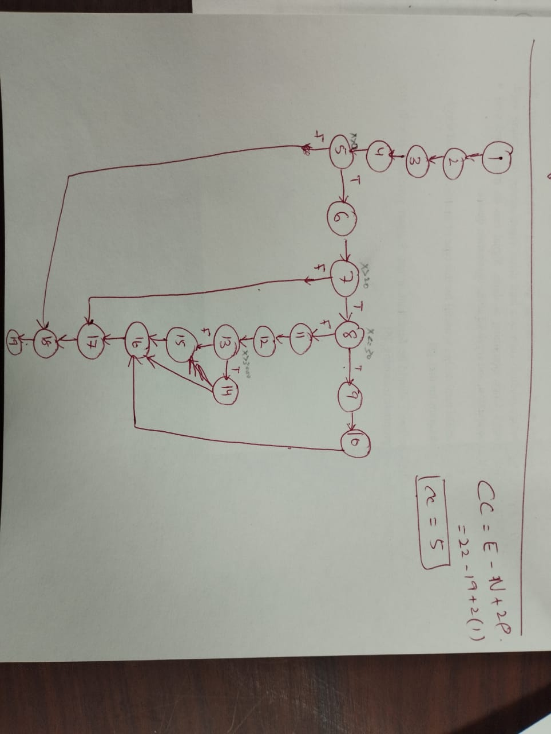a)

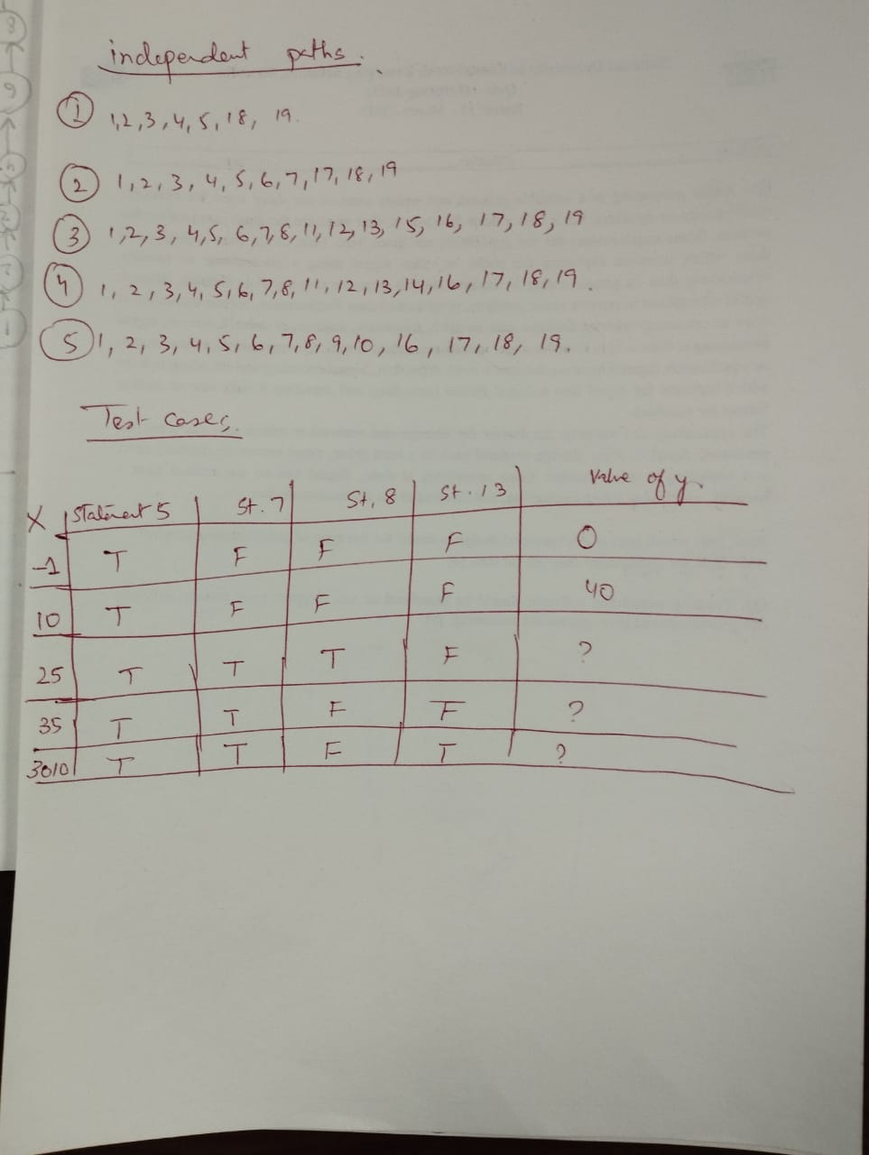

b)

*Functional:*

* Insert the card and an incorrect PIN to verify the message.
* Verify the message when there is no cash in the ATM.
* Verify the messages after a transaction.
* Verify if a user will get a correct message if a card is inserted incorrectly.
* Verify the functionality by entering a wrong pin number 3 or more times.
* Verify the card reader functionality by inserting an expired card.
* Verify the deposit slot functionality by inserting an invalid cheque.
* Verify the cash withdrawal functionality by inserting invalid numbers like 10, 20, 50 etc.
* Verify the cash withdrawal functionality by entering an amount greater than the per day limit,
* Verify the cash withdrawal functionality by entering an amount greater than per transaction limit.
* Verify the cash withdrawal functionality by entering an amount greater than the available balance in the account.

*Non – functional:*

* Verify the timeout session functionality.
* Verify the text color and font of the data on the screen. The user should be able to read it clearly.
* Verify the language selection option. If the messages or data are displayed in the selected language